Lab: Personal Expense Tracker
You have been asked to develop a Personal Expense Tracker for university students. The application should allow users to record their income and expenses, monitor their financial balance, and review their transaction history.
The application must work entirely on the client side. No backend server or database is required.

Task 1: Create the user interface
Create a responsive web application with the following components:
- A navigation bar displaying the application name, Personal Expense Tracker.
- Three summary cards showing:
  - Total Income
  - Total Expenses
  - Current Balance
- A transaction form containing:
  - Transaction type: Income or Expense
  - Description
  - Amount
  - Category
  - Date
- A transaction history table containing the date, description, type, category, amount, and action buttons.
- A filter that allows users to view all transactions, income only, or expenses only.
- A clear button to reset the form.
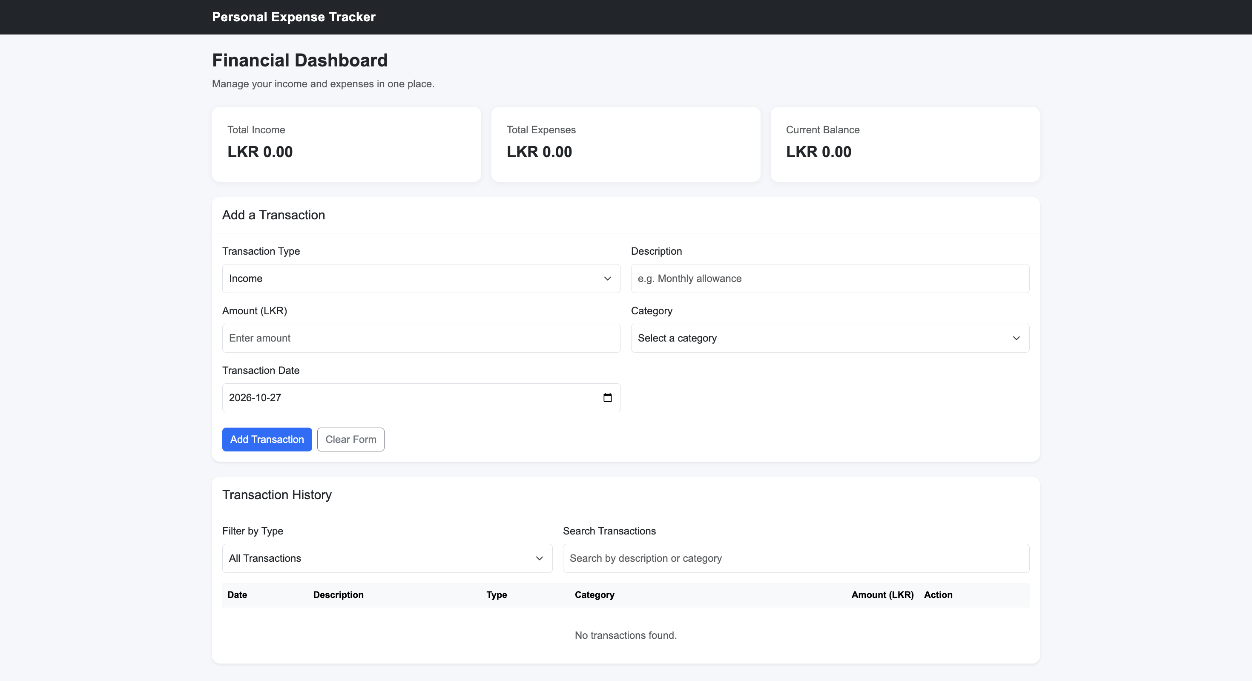

Task 2: Implement the functionality
Implement the following features using JavaScript.
Requirement | Description
Add transaction | Add a valid income or expense to the transaction list.
Form validation | Ensure that required fields are completed and the amount is greater than zero.
Calculate totals | Calculate total income, total expenses, and the current balance.
Dynamic table | Update the transaction table whenever a transaction is added or deleted.
Filter transactions | Display all transactions or only income or expenses.
Delete transaction | Allow users to delete an existing transaction.
Persistent storage | Save transactions in localStorage and restore them after refreshing the browser.
Responsive design | Ensure that the interface works on desktop and mobile screens.

Task 3: Test the application
Use the following data to test your application.
Type | Description | Category | Amount (LKR)
Income | Monthly Allowance | Allowance | 25,000
Expense | Lunch | Food | 800
Expense | Bus Fare | Transport | 250
Income | Part-time Work | Salary | 5,000
Expected results after entering all four transactions:
Income

LKR 30,000
Expenses

LKR 1,050
Balance

LKR 28,950

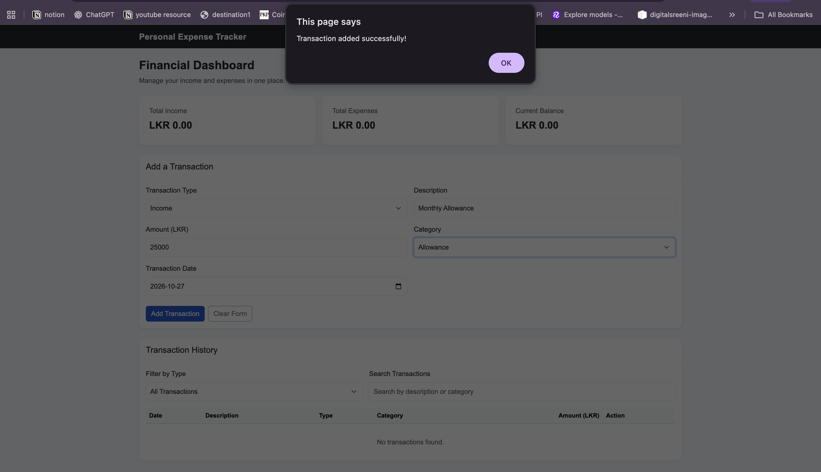

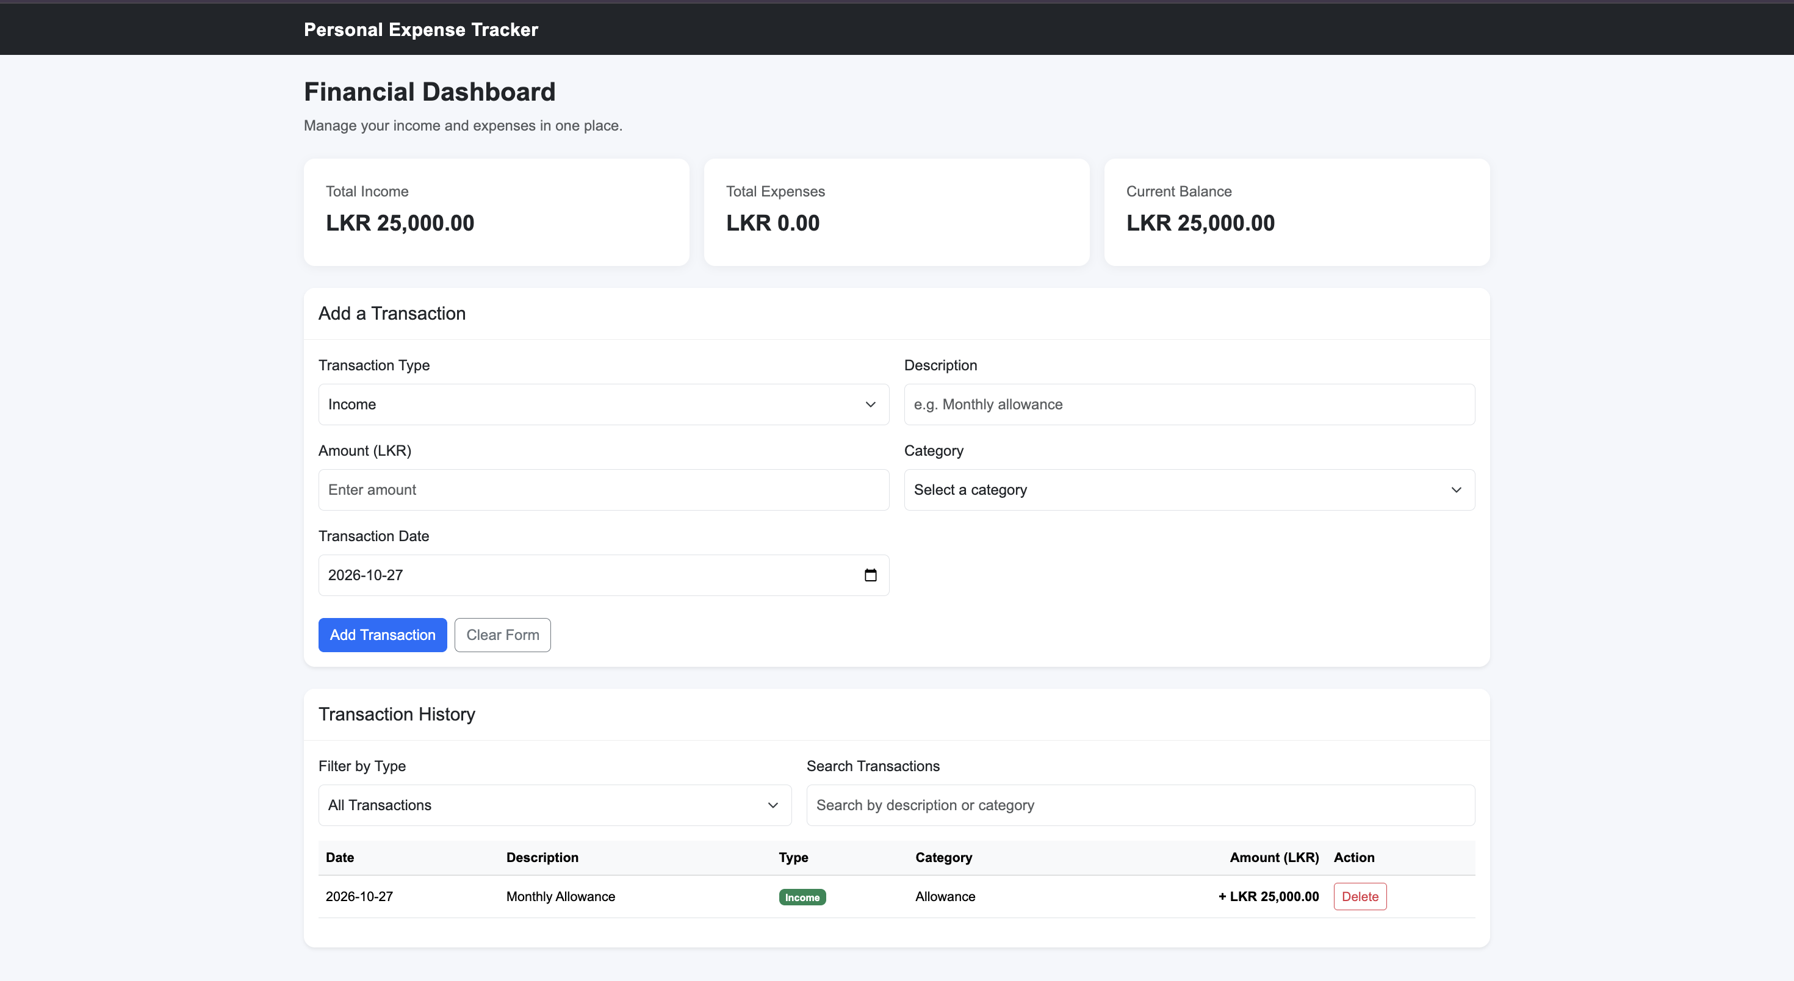

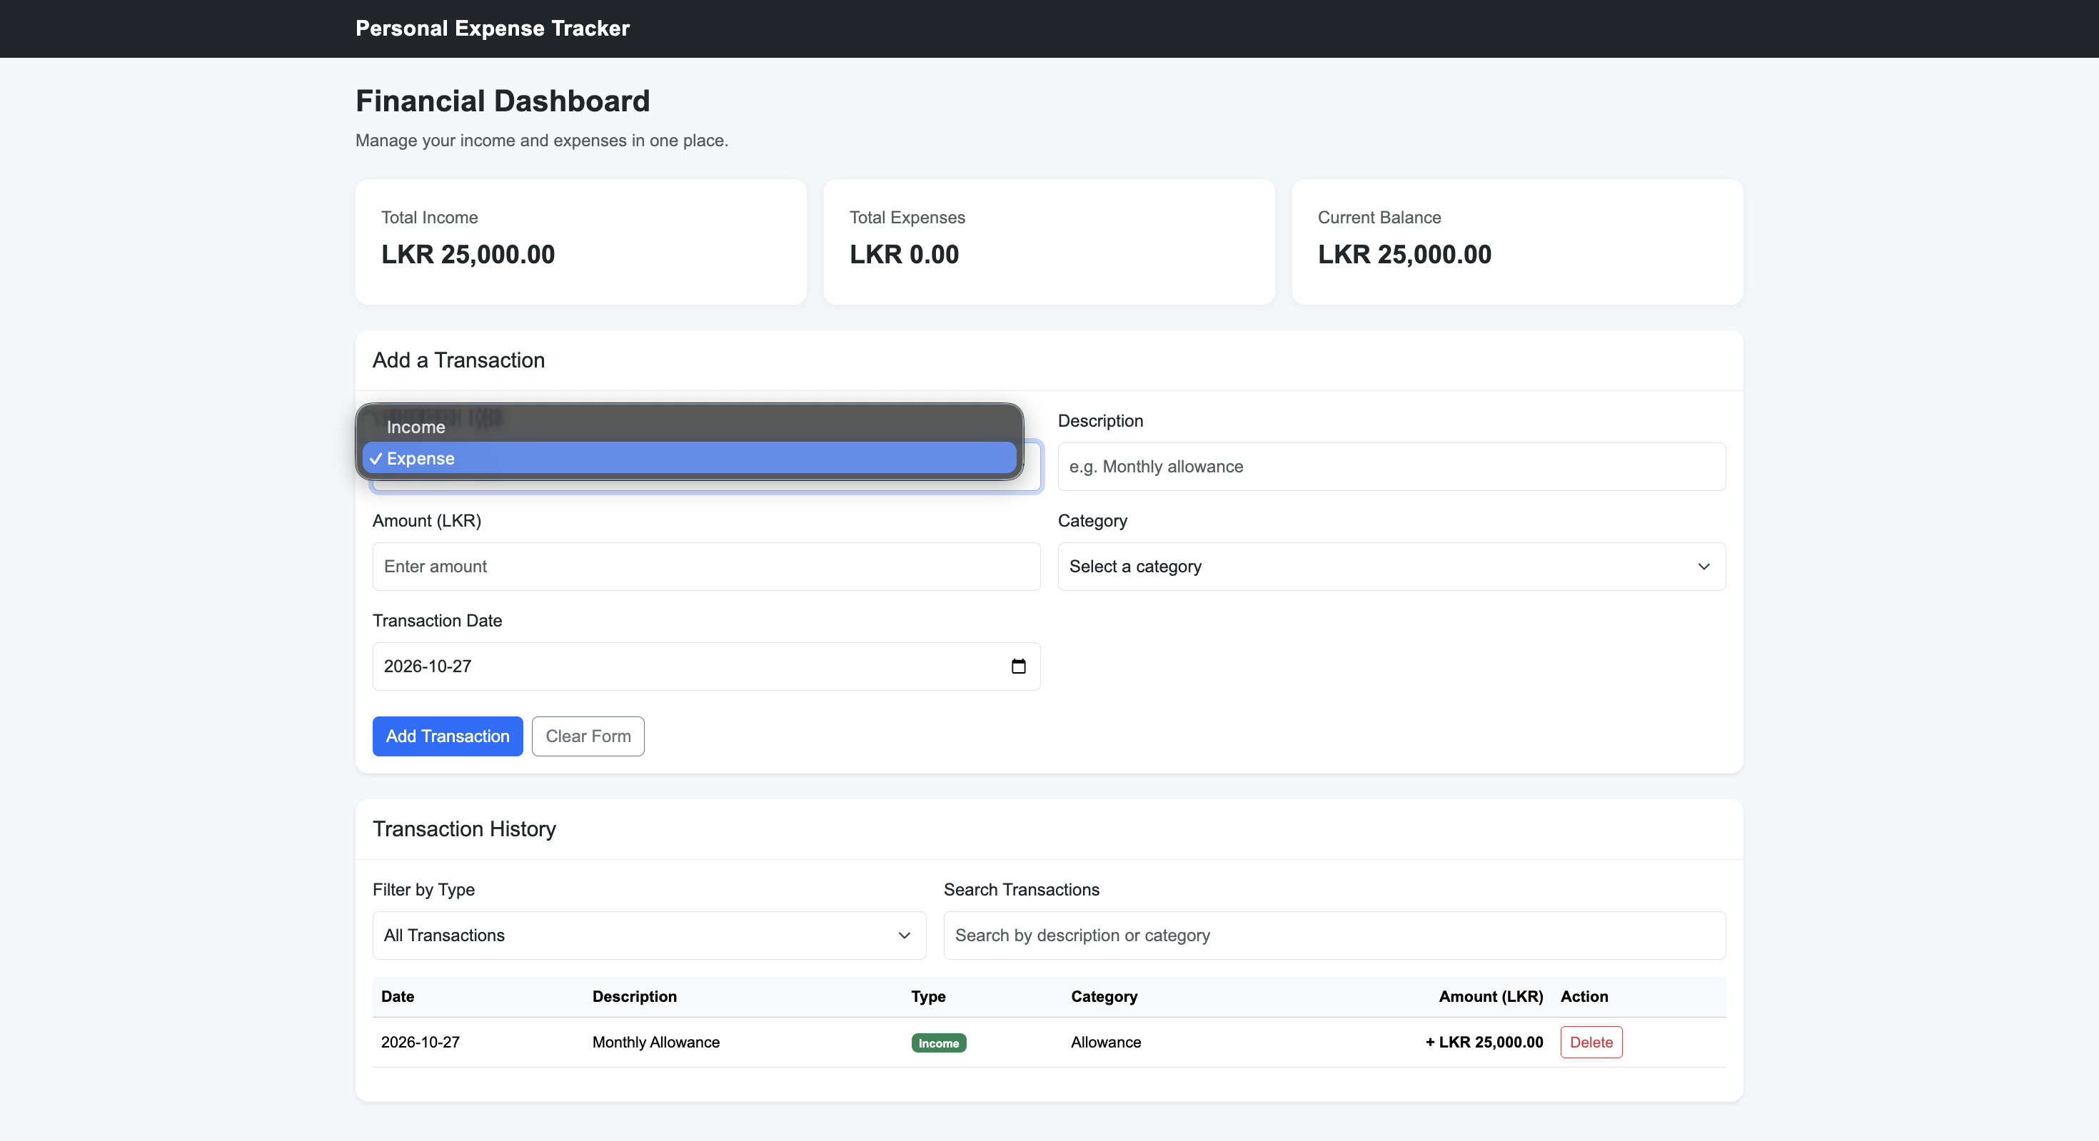

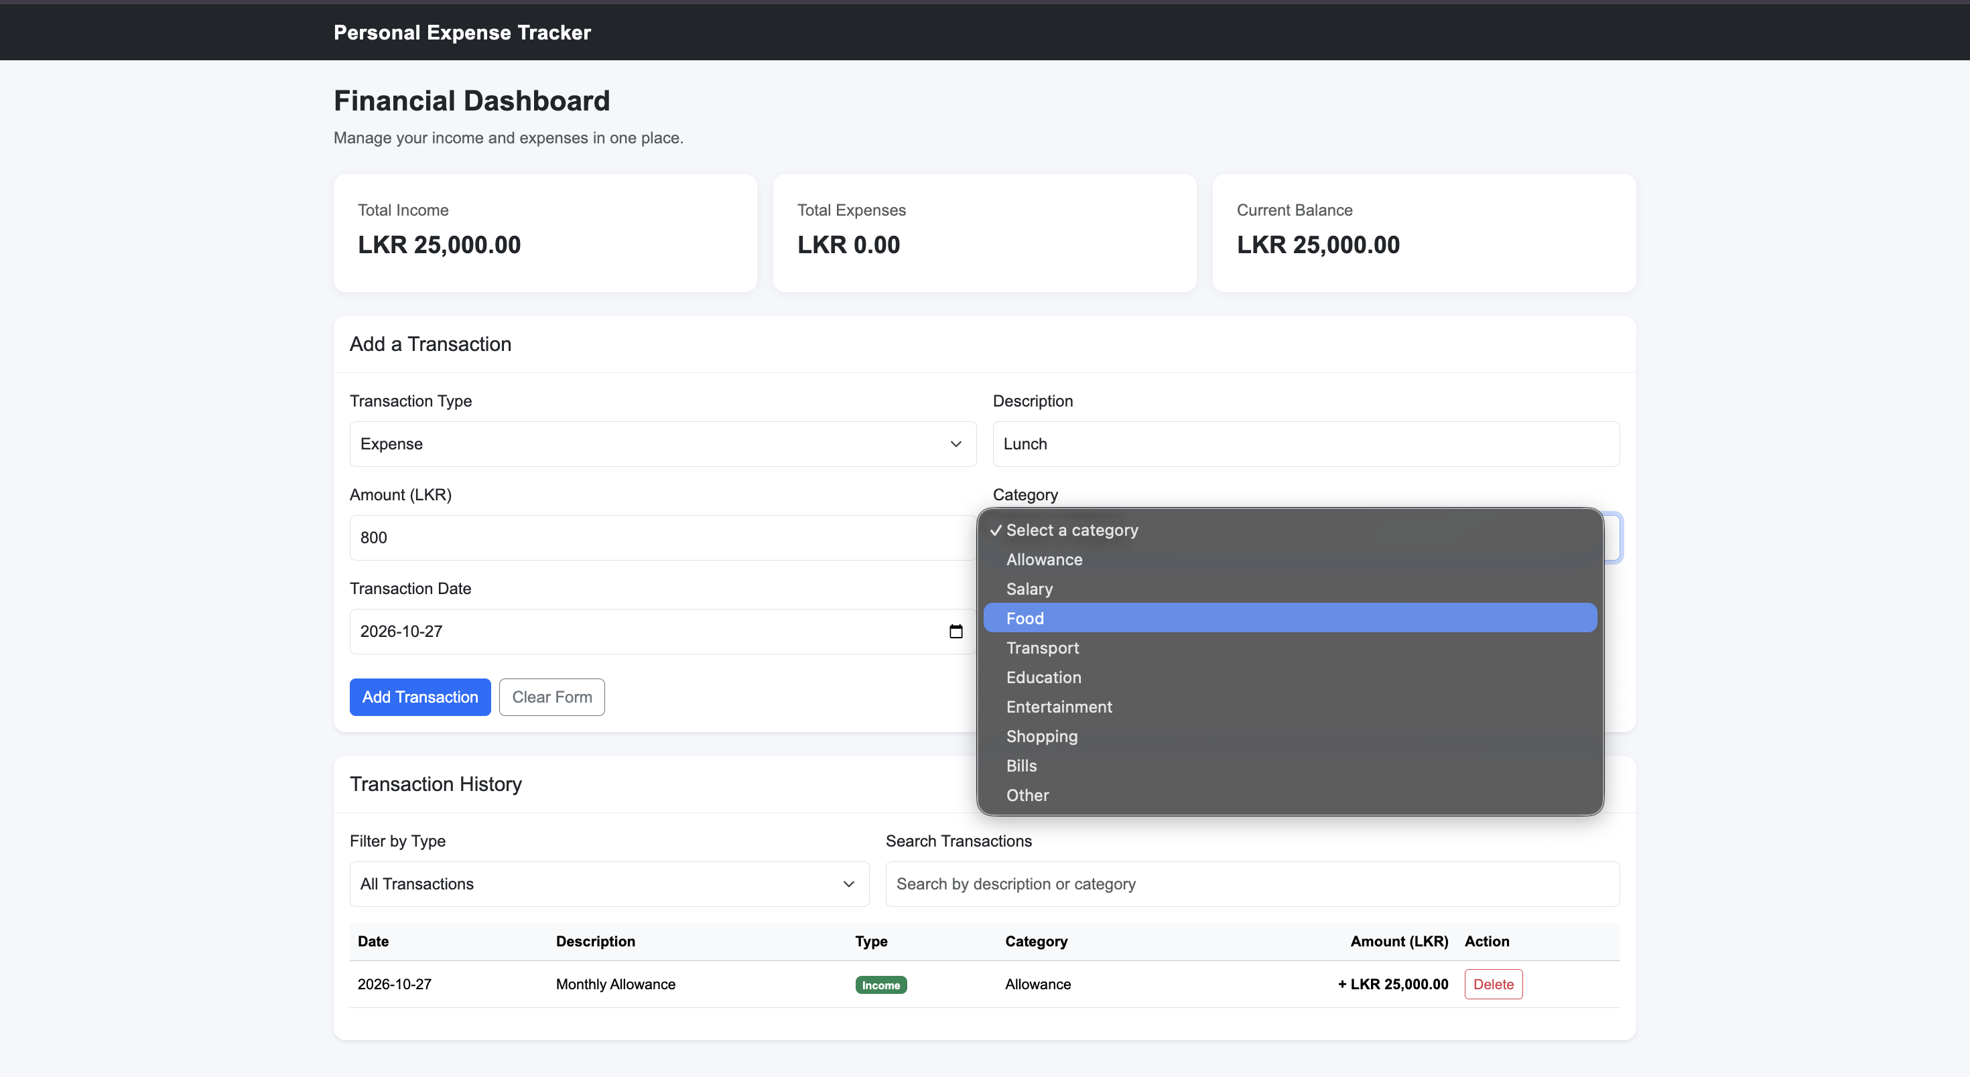

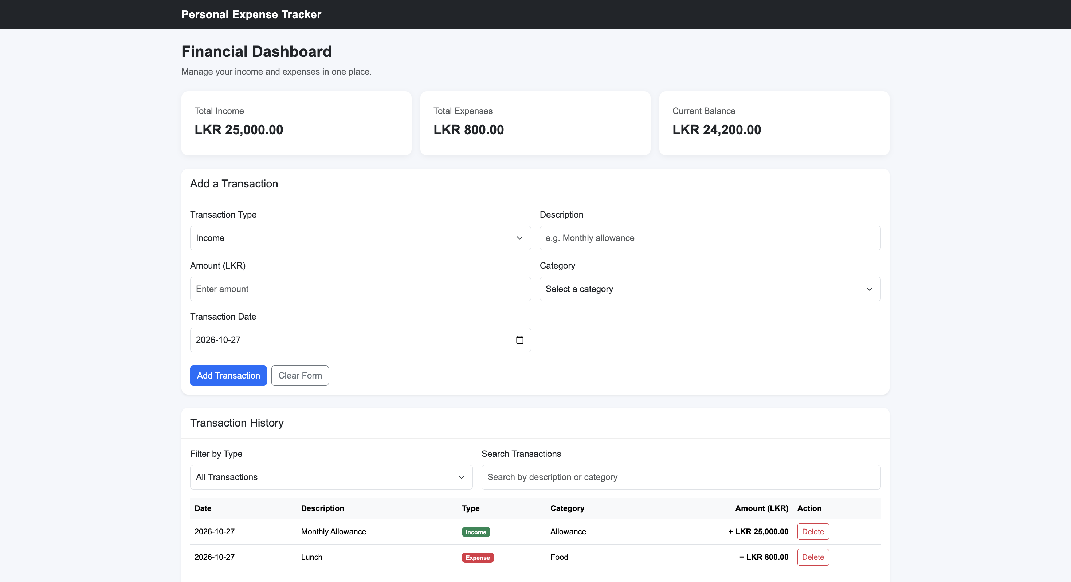

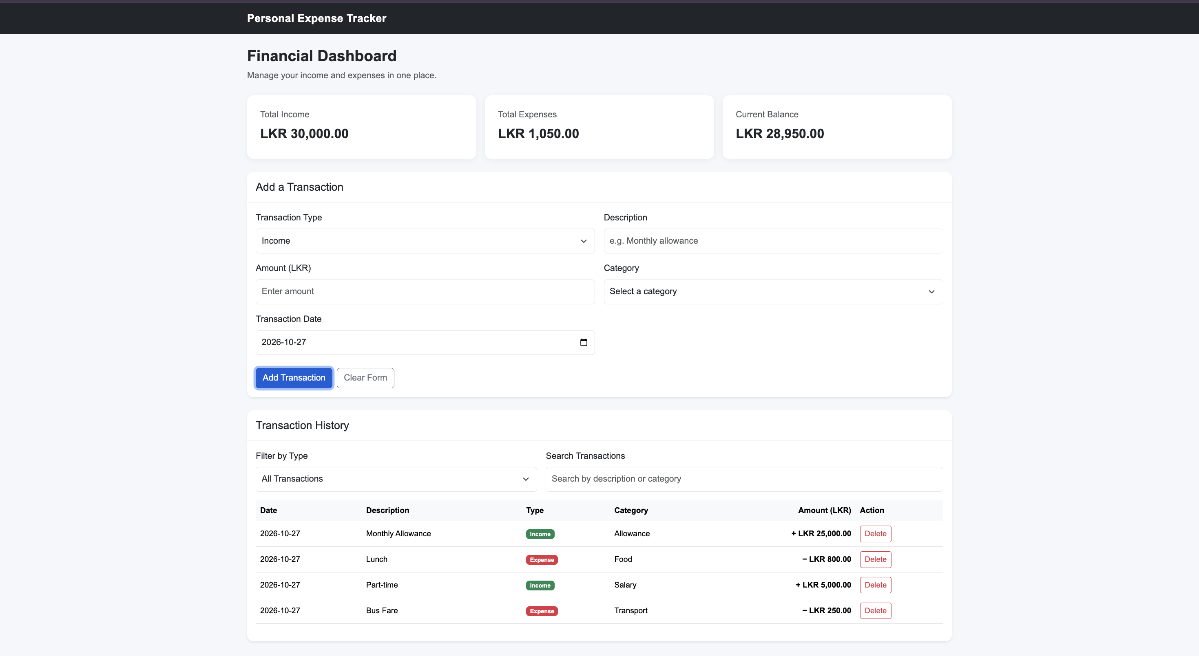

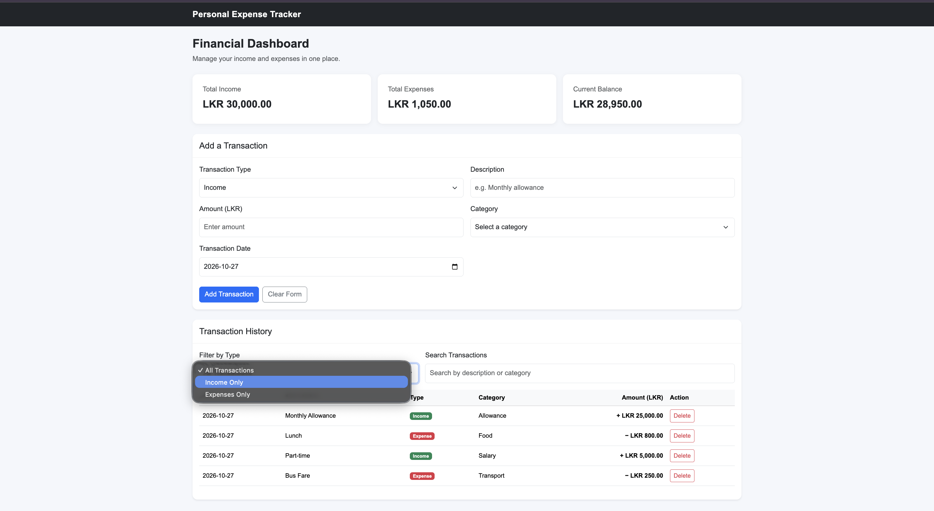

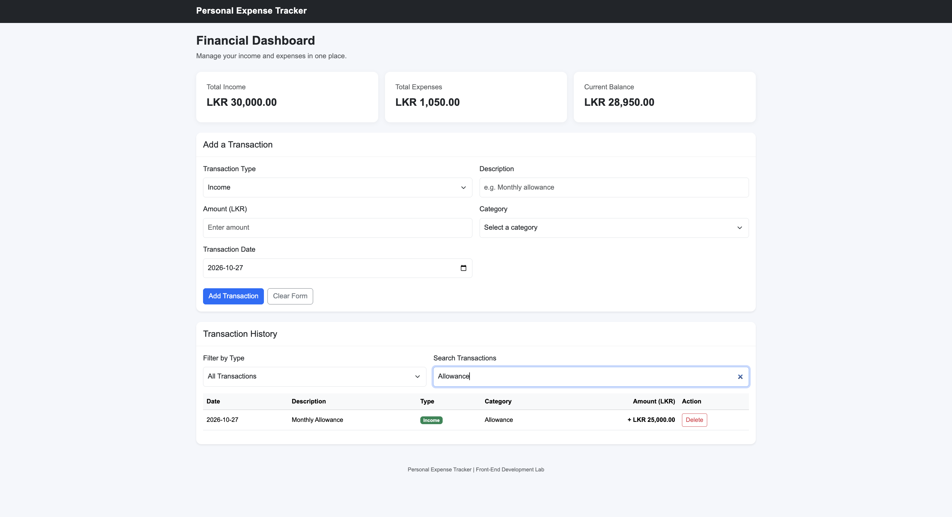

Task 4: Host the Personal Expense Tracker
Deploy the completed Personal Expense Tracker using a freely available hosting service.

Instructions
- Create a GitHub repository named personal-expense-tracker.
- Upload index.html, style.css, and script.js to the repository.
- Host the application using one of the following services:
  - GitHub Pages: https://pages.github.com/
  - Netlify: https://www.netlify.com/
  - Vercel: https://vercel.com/
- Verify that the hosted application works correctly in a web browser.
- Test adding, deleting, filtering, and searching transactions.
- Refresh the page and verify that previously saved transactions are still available.
- Submit both the GitHub repository URL and the deployed application URL.

Submission format
- GitHub Repository URL: ______________________________
- Hosted Application URL: ______________________________
Note: The application must be publicly accessible through the submitted URL. Ensure that all HTML, CSS, and JavaScript files are included and that the application functions correctly after deployment.

